OPC – SCHEDULING
Creating a new application

From the OPC Main Menu, enter 1.4.2 Option to create an application in OPC database.
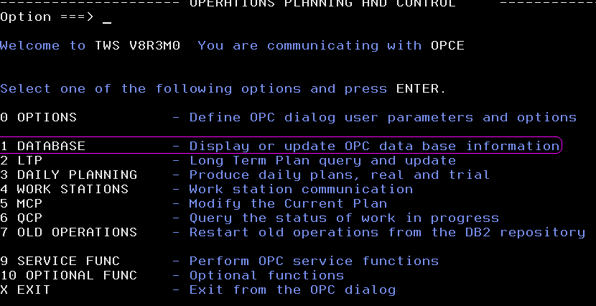
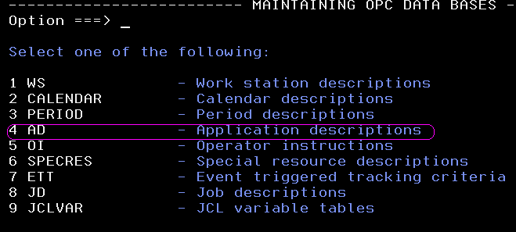

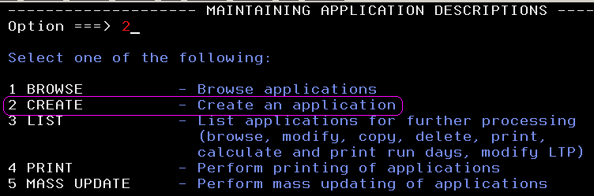

Now enter the application id (schedule) name, Ower ID, Type , Text , Priority and Status to create an application.
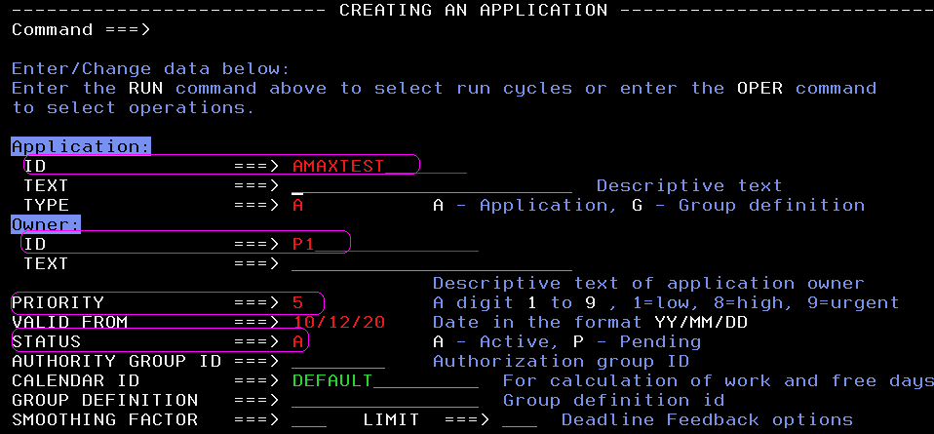

Now type ”OPER” in the command prompt to enter the operations / jobs within the application.
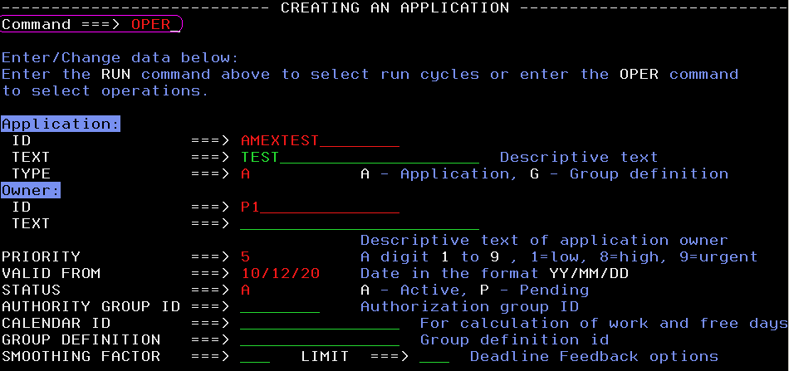
The operations screen is displayed as below:
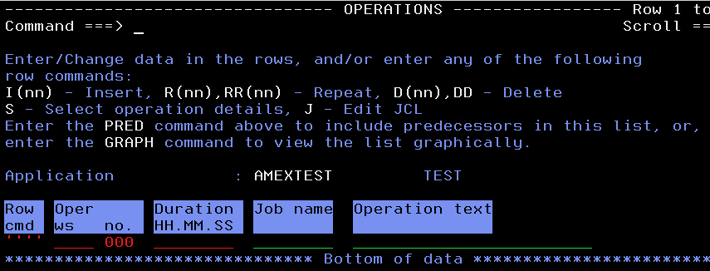
Enter “I” insert in the row command to insert an operation and enter the operation details.
Note: All operations representing jobs are specified to run on a specific workstation. Each workstation supports one activity.
The operation number is vital in assigning the internal predecessors. Generally, the workstation number varies from 001 to 099 .
The workstation numbers for each operation should be different and should be in ascending order.

Enter the workstation name, number, Job name and Description of the job in the Operation Text fields as below and enter the command PRED to include predecessors.
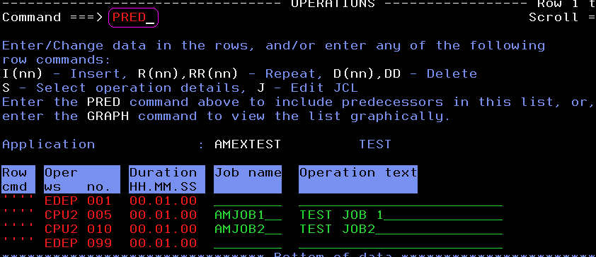
Below screen appears where predecessors can be included for the operations.
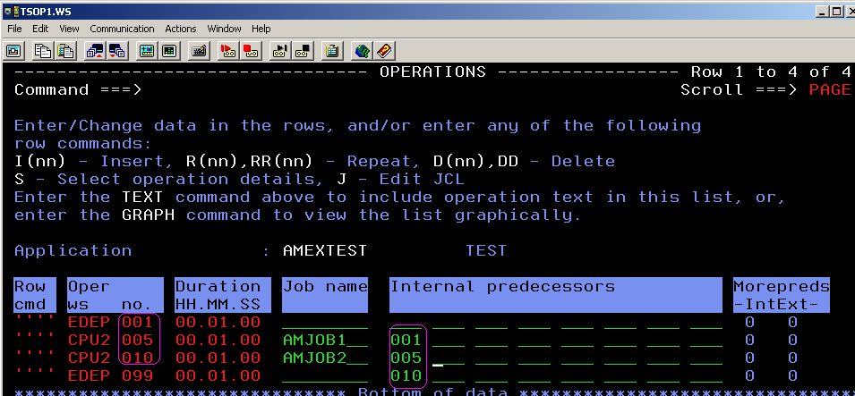
In the above screen shot, the scenario is after the application starts with EDEP, the job AMJOB1 starts. After the job AMJOB1 is complete AMJOB2 starts and once it is completed the application also completes EDEP.
We can also have AMJOB1 and AMJOB2 run simultaneously after EDEP 01 of the application by specifying the internal predecessors as 01 for both the jobs.
The command TEXT is used to open the screen to include operation text.

Enter the option S in the command prompt for any operation which leads to Operation Details screen.
Select the options according to the requirement.

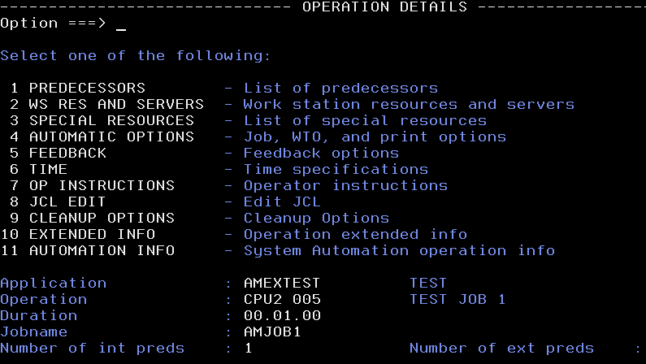
Options:
7 – To Create / Modify / Copy / Delete an Operator Instruction
3 – To specify the special resource used by that Operation
1 – To specify the predecessors for the Operation.
4 – To specify if a job is Time Dependent and also the printing options.
6 – To specify the input arrival of the operation, duration of the job, etc

ADDING THE OPERATOR INSTRUCTIONS TO A JOB:
Select option 7 to insert Operator Instructions. The below screen is displayed with options to browse (if existing), Modify , Copy and delete. You can create an instruction using “CREATE” command.
Note: The operator instuction listed after entering Option 7 from the above screen depends on the Operation Number . The Operation Number in the example is “5” and since there is no Op Instruction associated with that number, the screen is displayed blank with no Op Instructions. Else the instruction is displayed and it can be either modified or copied or deleted.

Entering the CREATE command allows you to edit and add an instruction associated with the Operation Number (Ex: 3)
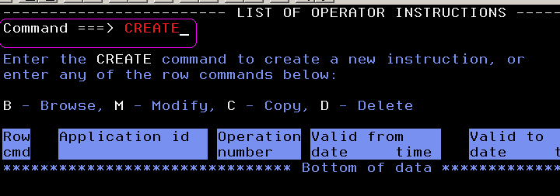
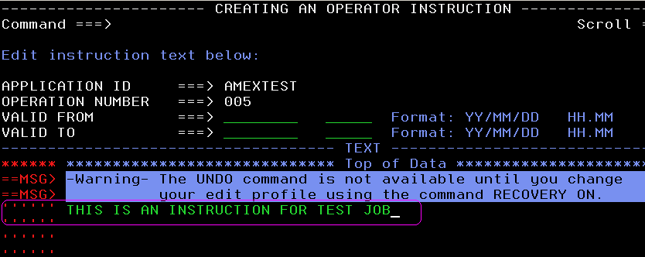
Press F3 to save the instructions.

TO MAKE A JOB TIME DEPENDENT
Select the option 4 ( automatic options) from operation details screen
Enter Y in the Time Dependent filed.
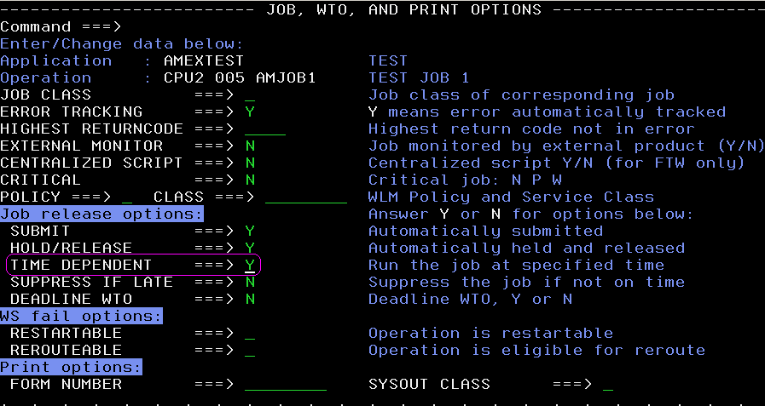
Press F3 to go back to the Operation details screen and select Option 6(TIME) to enter the Time Specifications.
Enter the Operation Input arrival day and time and also the Operation Deadline day and time.
Note: 0 in the day specifies the same day. Press F3 twice to save and exit.
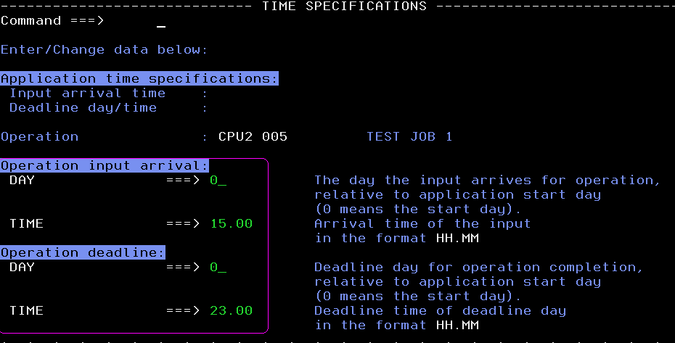
Thus, the application becomes Time Dependent and starts only at the specified time as mentioned in the Input Arrival Time details.

ADDING EXTERNAL PREDECESSORS
Select Option 1 – Predecessors from the operation details screen
Enter the application name in case of inserting an application as a predecessor. In the below screen all the applications which start with AMACM are displayed.
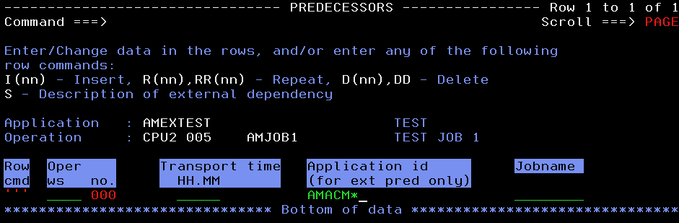
You can select a specific application by giving S in the row command
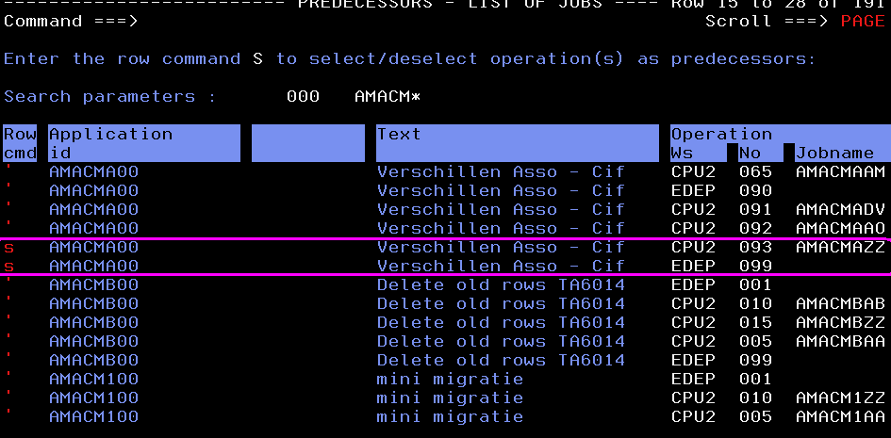
Note: Selecting the AMACMAM with workstation CPU2 and operation 93 selects only the job as the predecessor for an operation.
Selecting the EDEP with workstation 099 makes the entire application as the predecessor.
Press F3 to save and exit. You can find the predecessors added to it

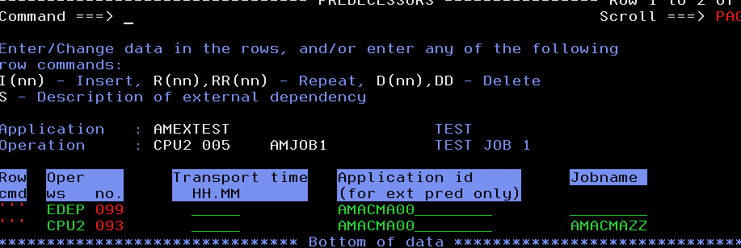

ADDING RUN CYCLES
Type the RUN in the command prompt and enter for adding run cycles to an application.
Note: If a Group Definition field is filled, you cannot add run cycles to it as the group must have had defined cycles in it.
So, leave the Group Definition field blank and give RUN in the command prompt. Below screen is displayed.
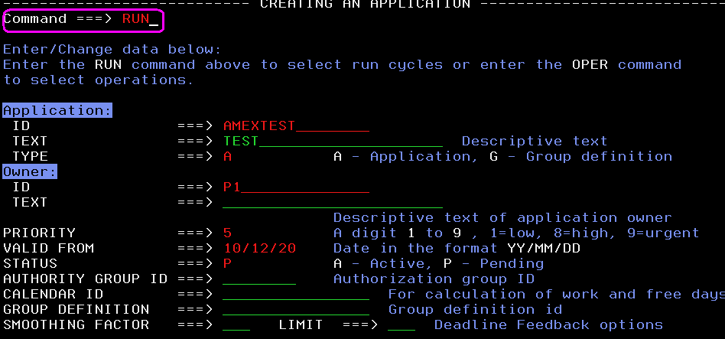

To know what each field corresponds to and the options in it, press F1.
Fields:
Name of the period or Rule - Give any name for the period or Rule you are defining.
Input HH:MM – Give the input arrival time
Deadline – Give the dead line time
Type – R/E
R - Rule based run cycle / E- Exclusive rule based run cycles
N - Offset-based normal run cycle / X - Offset-based negative run cycle.

F day Rule – E - Exclude Free days
1 - Moved to the closest work day before the free day.
2 - Moved to the closest work day after the free day.
3 - Run on the free day.
4 - Do not run.

Enter “s” near the rule to specify the run days and to modify the rule in the above screen.
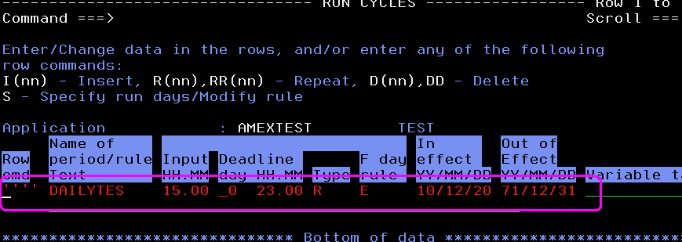
Enter “s” in the selected frequency, day, cycle specification, etc. Define the rule by placing an S in the appropriate field and enter GENDAYS command to view the calendar on which the application is scheduled to run.
Enter GENDAYS in the command prompt to see the dates of the calendar on which it is specified to run.
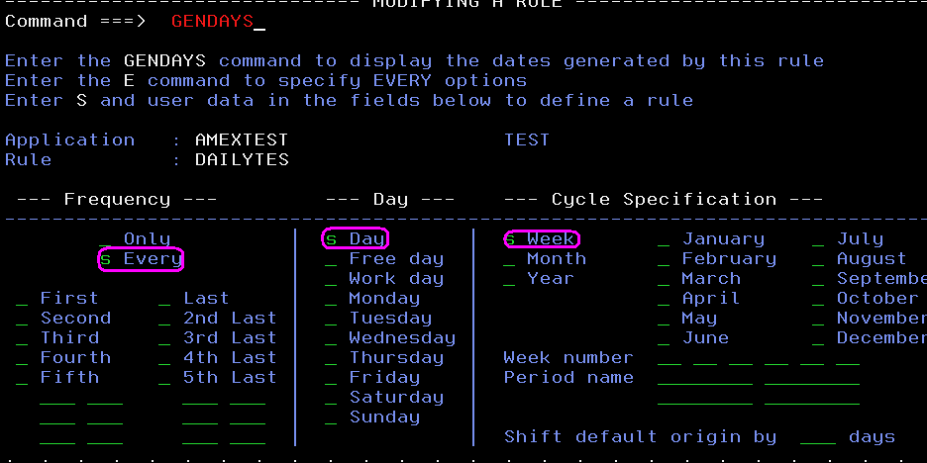
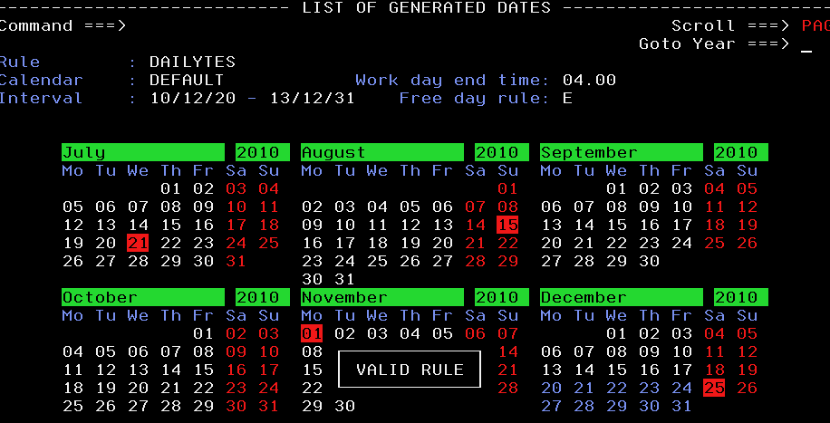
Press F3 to save the rule. You find an alert “Valid Rule” when saved.
In the above rule, the schedule is time dependent and runs on every day in the week excluding the free days (holidays) and on weekends.

